MEMORANDUM |  | 
To: | Charlie Refvem, Department of Mechanical Engineering, Cal Poly SLO
 | crefvem@calpoly.edu
From: | Caiden Bonney
 | clbonney@calpoly.edu
Date: | October 19th, 2025
RE: | Homework 0x03 - System Modeling

Overview and Schematic
The first step in developing a simplified model of Romi’s dynamics is to clearly establish the geometry and motion of Romi. Figure 1 illustrates Romi’s geometry, defining variables corresponding to its track width and wheel radius as well as correlating the directions of the velocity vectors and rotation of Romi to a coordinate system. This will serve as the foundation for accurately representing Romi’s kinematic motion in a 2D plane.
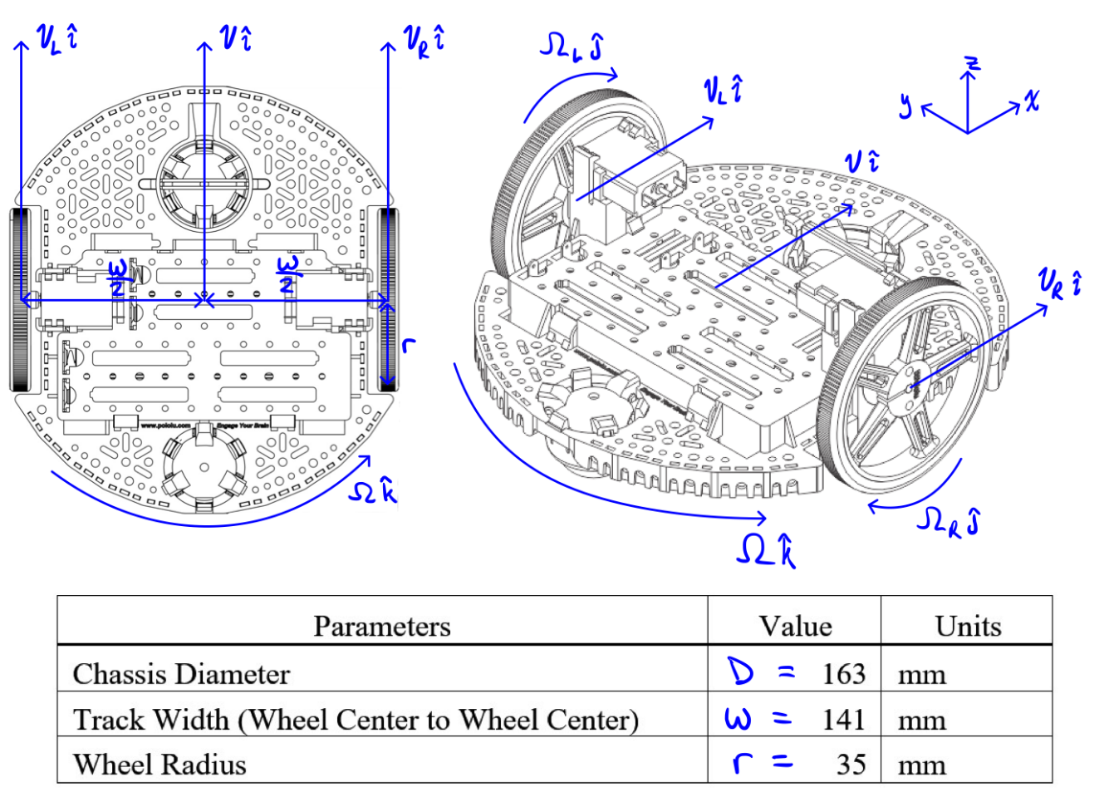
Figure 1. Romi’s geometry and defining directions of motion in terms of its local coordinate system
Figure 1 depicts Romi in relation to its defined local coordinate system in which the x direction corresponds to forward movement the z direction with vertical movement and the y direction with horizontal movement. The local coordinate system moves with Romi meaning that anywhere in the environment if Romi is moving “forward” it is moving in the positive x direction. Figure 1 also defines crucial directions for $Ω_{L}$ and $Ω_{R}$ in which positive motion corresponds to forward movement. At the base of Figure 1 the parameters that depend on Romi’s geometry are defined, such as the radius of both wheels, r, and the track width, w.

Kinematics
Applying the equations of the no-slip condition and general motion in a 2D plane we can derive the equation for the yaw rate and velocity of Romi in the local coordinate system. These equations are derived in Figure 2.
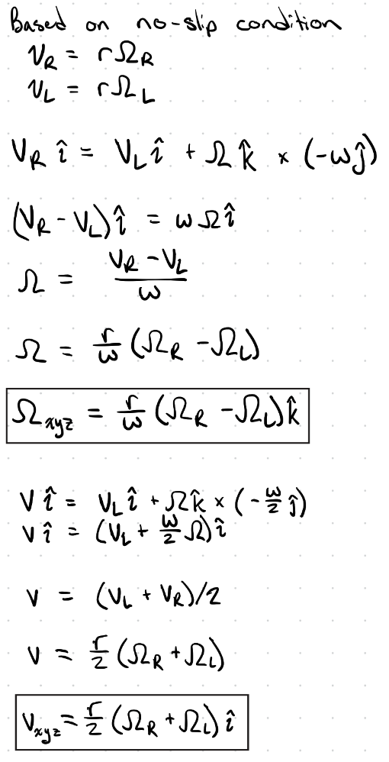
Figure 2. Derivation of yaw rate and central velocity of Romi in the local coordinate system
The yaw rate and velocity of Romi are written in terms of the angular velocity of each wheel as well as constants defined in Figure 1. The angular velocity of each wheel can be measured through the use of encoders placed on each wheel’s motors. Therefore, at any point in Romi’s operation the yaw rate and velocity of Romi can be calculated based on its current position. To keep track of Romi’s absolute location a global coordinate system must be created.

Coordinate System
Defining the local coordinate system relative to the global coordinate system allows Romi to keep track of overall position based on its starting position. Figure 3 depicts an illustration of the connection between Romi’s position in local coordinates versus global coordinates through the yaw angle of Romi.
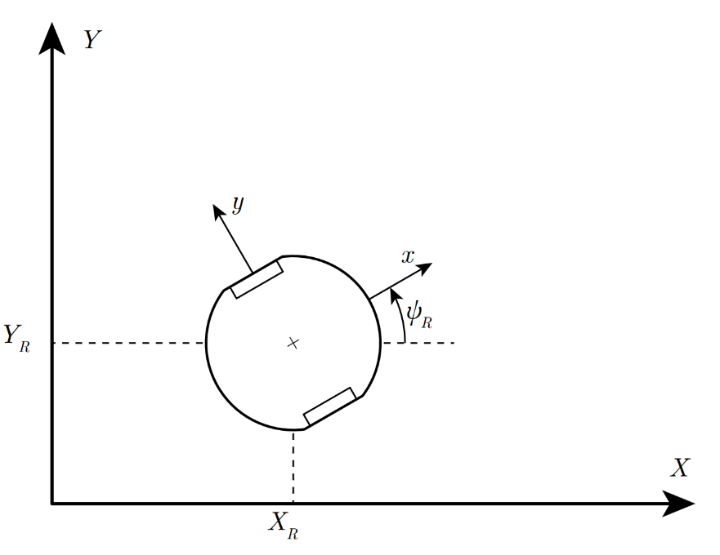
Figure 3. Romi’s global and local coordinate systems
Based on this yaw angle, $ψ_{R}$, the relationship between the global and local coordinate systems can be defined through a coordinate transformation matrix.
$$\left[\begin{matrix}\hat{i} \\ \hat{j}\end{matrix}\right]=\left[\begin{matrix}cosψ_{R} & sinψ_{R} \\ -sinψ_{R} & cosψ_{R}\end{matrix}\right]\left[\begin{matrix}\hat{I} \\ \hat{J}\end{matrix}\right]$$
Expanding this coordinate transformation matrix.
$$\hat{i}=cosψ_{R} \hat{I}+sinψ_{R}\hat{J} \\ \hat{j}=-sinψ_{R} \hat{I}+cosψ_{R}\hat{J}$$
Since velocity of Romi, v, in the local coordinate system is only in the positive x direction, the, $\hat{i}$, can be substituted for its transformation to determine $X_{R}$ and $Y_{R}$ in Figure 4.
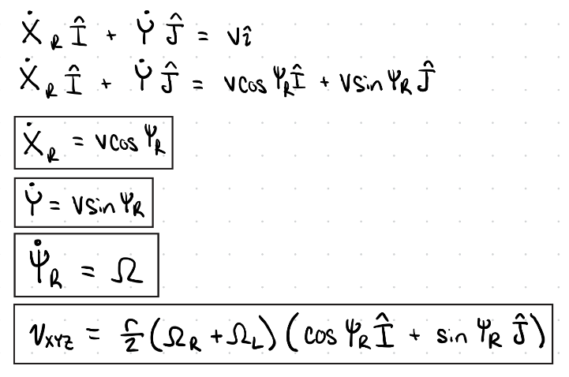
Figure 4. Derivation of Romi’s central velocity in global coordinates
The angular acceleration of each of Romi’s wheels depends upon 4 factors, the current speed of the motor (Romi’s current wheel speed), $Ω_{m}$, the applied voltage, $u_{m}$, the time constant of the motor used, $τ_{m}$, and the motor’s gain, $K_{m}$. The equation relating these 4 factors together is shown in Figure 5.
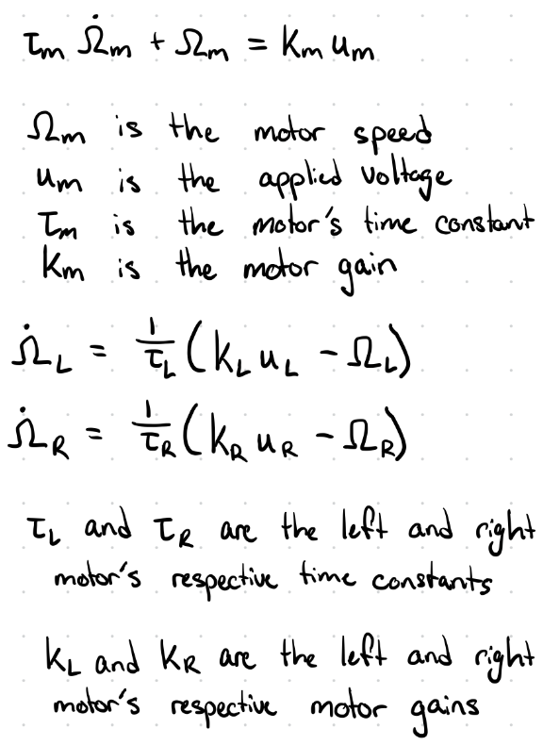
Figure 5. Romi’s angular acceleration for both wheel’s
The left and right wheel’s motor’s gains and time constants can be determined experimentally through a step response test. Therefore, based on the given input voltage the angular acceleration of Romi’s wheels can be analytically solved for at any point during its operation assuming that its time constant and gain remain the same for all input voltage values and at all speeds.
Incorporating all kinematic relationships previously discussed into a set of state equations represented by the form $\dot{x}$ = f(x, u) in which x represents the state variables and u are the system inputs. The desired output parameters are determined by y which defines the output equations in terms of the inputs state variables found in x.
Defining state variables, system inputs, and output variables.
$x$ = $\left[\begin{matrix}X_{R} \\ Y_{R} \\ ψ_{R} \\ s \\ Ω_{L} \\ Ω_{R}\end{matrix}\right]$, $u$ = $\left[\begin{matrix}u_{L} \\ u_{R}\end{matrix}\right]$, $y$ = $\left[\begin{matrix}X_{R} \\ Y_{R} \\ ψ_{R} \\ s \\ v \\ Ω\end{matrix}\right]$
The state variables are, the x coordinate of Romi in global coordinates, $X_{R}$, the y coordinate of Romi in global coordinates, $Y_{R}$, the yaw angle of Romi relating the x-axis of the local coordinates of Romi to x-axis of the global coordinates of Romi, $ψ_{R}$, the total signed distance Romi moved, $s$, and the angular velocity of both the left and right wheels respectively, $Ω_{L}$, $Ω_{R}$. The inputs are the volage supplied to both the left and right wheels respectively, $u_{L}$, $u_{R}$. The outputs are roughly the same with the only 2 changes being Romi’s instantaneous velocity, $v$, and the yaw rate of Romi’s chassis, $Ω$. After compiling all first order ordinary differential equations calculated from Figures 2 through 5 the overall state space models are depicted in matrix form.
$\dot{x}$ = $\left[\begin{matrix}{\dot{X}}_{R} \\ {\dot{Y}}_{R} \\ {\dot{ψ}}_{R} \\ \dot{s} \\ {\dot{Ω}}_{L} \\ {\dot{Ω}}_{R}\end{matrix}\right]=\left[\begin{matrix}\frac{r}{2}\left(Ω_{R}+Ω_{L}\right)cosψ_{R} \\ \frac{r}{2}\left(Ω_{R}+Ω_{L}\right)sinψ_{R} \\ \frac{r}{w}\left(Ω_{R}-Ω_{L}\right) \\ \frac{r}{2}\left(Ω_{R}+Ω_{L}\right) \\ \frac{1}{τ_{L}}\left(K_{L}u_{L}-Ω_{L}\right) \\ \frac{1}{τ_{R}}\left(K_{R}u_{R}-Ω_{R}\right)\end{matrix}\right]$
$y$ = $\left[\begin{matrix}X_{R} \\ Y_{R} \\ ψ_{R} \\ s \\ \frac{r}{2}\left(Ω_{R}+Ω_{L}\right) \\ \frac{r}{w}\left(Ω_{R}-Ω_{L}\right)\end{matrix}\right]$

Model Evaluation and Discussion
The assumptions behind the kinematic model can be evaluated by comparing them to those made in a full dynamic model. The no-slip assumption, in which both wheels roll without slipping is generally valid for Romi when it moves slowly on smooth high-friction surfaces. However, in the real world there exists many other factors that play a large role in the dynamics of the situation such as motor non-linearity, static friction, gear backlash, uneven weight distribution, and dissimilarities between the two motors. There are delays from the non-linear torque behavior that the simple kinematic model does not account for which can lead to slippage of the wheels causing the accuracy of the global position to gradually degrade over the course of the operation of Romi. If Romi moves at a moderate speed for shorter distances the kinematic model is accurate enough; Combined with information from additional sensors to adjust for these small errors the simpler kinematic model will be adequate for the use case.
It is not valid to assume that the motor parameters while driving forward are the same as the parameters when turning. When driving forward both motors must move their wheel’s inertia and roughly half of the inertia of Romi if the weight is distributed roughly evenly across it. However, when turning, the rotational inertia of Romi’s chassis in the yaw direction about the other wheel will introduce extra effects that change the parameters. Turning introduces the effects of Romi’s current momentum on the wheels which may lead to slipping as the motors will exhibit a different torque profile due to the additional force required to overcome this momentum and rotational inertia.
By measuring current and additional sensors we can calculate the expected position based on multiple inputs to verify the accuracy of our readings. For example, adding an inertial measurement unit (IMU) would provide absolute orientation, a direct measurement of angular velocity and acceleration, as well as a measurement of linear acceleration. Using this data the current velocity can be calculated and the velocity used for future integration can be an average of the velocities calculated through additional measurements. By measuring the acceleration, it may be able to track the possibility of slippage across the lengths of driving.
By measuring the encoders’ angular velocities and converting them to linear velocity using the relationships shown in Figure 2, the motor effort (and therefore voltage input) can be adjusted to reach a desired set speed. Implementing a PID control loop allows for automatic correction of velocity errors, and incorporating data from additional sensors such as the IMU provides a more accurate estimate of Romi’s true motion. Integrating this sensor data over time enables a more precise determination of Romi’s absolute position. Additionally, dividing the robot’s path into distinct segments, such as straight lines, circular arcs, and in-place turns, makes it possible to apply different parameter sets or control strategies to each segment. Using different parameters for turning versus linear travel helps correct inaccuracies that arise from relying on the simpler kinematic model, as opposed to a full dynamic model in which Romi’s chassis rotational inertia and mass would be directly incorporated rather than estimated through step response tests.
It is not possible to determine Romi’s final orientation and position using only the total angles swept by each wheel as there are multiple different paths that can lead to the same final wheel angles. However, if the time history of each wheel’s rotation is known along with the initial position Romi’s path can be determined step by step by integrating its kinematic equations over time. This approach will be heavily affected by error as every slippage of the wheel or accumulated error due to noise will change Romi’s path greatly. The longer the path the larger this accumulated error becomes the further off the calculated orientation and position will be. To track Romi’s position accurately additional sensors should also be recorded with time stamps to ensure the readings align at the same time readings. Overall the encoder data, timestamps, wheel geometry (radius and track width) as well as the initial position and yaw angle are required to determine the final orientation and position with any additional sensor readings increasing fidelity of the final result.

References:
- Refvem, C. (2025). Homework 0x03 - System Modeling [Unpublished homework instructions]. Department of Mechanical Engineering, Cal Poly. Retrieved from https://canvas.calpoly.edu/courses/161863/assignments/1368599?module_item_id=4790183
- Refvem, C. (2025). Lecture 11 – Romi Dynamics [Unpublished lecture notes]. Department of Mechanical Engineering, Cal Poly.

